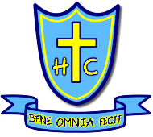
Holy Cross Primary School
Writing Journey

Writing
As a school we use Talk for Writing as our framework for writing. This is used alongside the National Curriculum and the Read Write Inc. Phonics and Spelling program to ensure high-quality teaching of writing across the school.

At the heart of English teaching in Holy Cross is the Pie Corbett ‘Talk for Writing’ approach. Talk for Writing enables children to become immersed within a high quality, age appropriate text, then to understand and imitate the key language they need before they try reading and analysing it. Through fun activities that help them rehearse the tune of the language they need, followed by shared writing to show them how to craft their writing, children are helped to write in the same style.

Independent and shared writing opportunities are provided throughout each unit.
One long write takes place at the beginning and end of the unit, with shorter writing opportunities provided throughout the early stages of the cycle and other longer independent writes built in throughout. To help build the stamina of our writers, opportunities across the curriculum are provided for children to explore their writing style.

Our modelled writing and use of Talk for Writing structures are used across the school to develop the skills and strategies that children need to integrate the wider range of sentence structures into their work.

Assessment
Across each year there are three data captures, Autumn, Spring and Summer.
Within each Talk for Writing unit, each teacher will give the children an opportunity for a pre-assessment write (to enable members of staff to assess prior knowledge) and an after unit assessment (at least two weeks after the unit has been completed, to assess retention and knowledge of a previously studied text type.
Moderation of writing happens within teams, in staff meetings and within Senior Leadership meetings. As a school we also use No More Marking - Comparative Judgement as a further method of supporting teacher judgements.

Genre Coverage
Our wider curriculum is taught using a curriculum cycle, split into ‘Years A and B’. Each year group has been given a ‘Year A / B’ plan for writing to ensure coverage of all text types for each year group, and the progression of key writing skills as the children progress through the school.

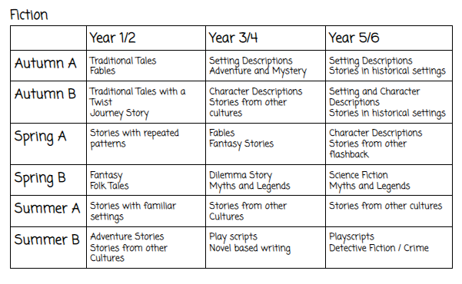
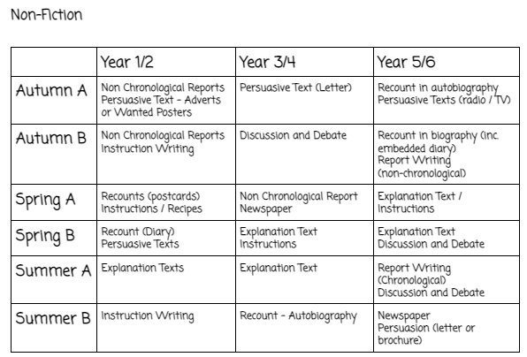

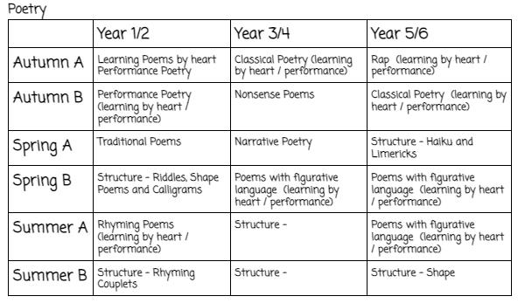

Talk For Writing
To teach writing across the school, we are using the Talk for Writing programme.

‘The Talk for Writing approach enables children to read and write independently for a variety of audiences and purposes within different subjects. A key feature is that children internalise the language structures needed to write through ‘talking the text’, as well as close reading. The approach moves from dependence towards independence, with the teacher using shared and guided teaching to develop the ability in children to write creatively and powerfully.
Schools underpin their English work by establishing a core reading spine of quality fiction, poetry and non-fiction that all children experience and draw upon. Imaginative units of work are developed to create a whole-school plan that is refined over the years, is well-resourced and documented to release teachers from planning and preparation so that they can focus on adapting their teaching for children’s learning.
The key phases of the Talk for Writing process, as outlined below, enable children to imitate orally the language they need for a particular topic, before reading and analysing it, and then writing their own version.’ Pie Corbett
This programme allows the children to develop their understanding of a range of genres and writing techniques through sharing of high-quality texts, teacher modelling, shared writing opportunities throughout units which culminate in independent writing from the children which demonstrates the wide range of skills that they have learnt.

EYFS
Writing within EYFS - Within their Read Write Inc sessions, the children will practise their writing every day. They begin by rehearsing out loud what they want to say before spelling out the words using the skills that they have developed. They practise their handwriting every day and learn correct letter formation, including joining. Children’s writing is developed by drawing on their own experience and talking about the wide range of texts that they are exposed to.

Alongside Read Write Inc, the children experience writing sessions which look at developing their phonics skills through writing: beginning with words that match their spoken sounds and moving into writing simple sentences, using high frequency words and irregular common words.

On entry to EYFS, the children will be assessed on their independent writing abilities, taking part in writing tasks such as writing their name and / or drawing and labelling pictures of their family. This gives staff the opportunity to assess fine and gross motor skills and the child’s ability to form patterns and letter shapes. This work goes alongside observation with the learning environment through the range of writing opportunities and activities that are provided.

Teachers use Talk for Writing in EYFS to teach writing, using high quality stories for their chosen story maps. This process will include lots of listening to stories, lots of repetition of stories and lots of interaction with the text that they are learning.

Key Stage One
Within Key Stage One we continue to use the Read Write Inc phonics and the Talk for Writing programs to teach English.
Each Key Stage One class will have 5 phonics lessons a week, 3 whole class reading sessions a week and 4 writing lessons per week. Together, these sessions help the children to develop their phonics and reading skills, which has a direct impact on the children’s writing.
Within their Talk for Writing sessions the children are exposed to high quality texts, story maps and are able to explore a range of vocabulary, genre and Spelling, Punctuation and Grammar (SPAG) features.

Phonics and Spelling
Year One
In our phonics sessions, the children are taught the Year 1 common exception words, and will learn tricky words, spelling rules and how to sound out and blend words. They then apply these skills and key words within their independent writing in their English lessons.

Year Two
In Year 2, the children will continue to develop their phonics knowledge. They are aiming to read words by sight without having to sound them out. They will learn new spelling rules and spelling patterns and continue to apply the skills that they have learnt to their own independent reading.
Those who have failed the phonics screening check will have further intervention to address the gaps and misconceptions.
When the children are ready, those who have a good phonetic understanding are abie will move on to the Read Write Inc Spelling Unit for Year 2. Here they will look at the year 2 spelling rules and will complete a range of activities to help them to easily recall this knowledge and understanding. These spelling rules are also highlighted in other sessions to help the children to embed this knowledge.

Key Stage Two
Within Key Stage Two we use the Read Write Inc Spelling program to teach spelling, and the Talk for Writing program to teach Writing.
Each Key Stage Two class will have 5 spelling lessons a week, 4 whole class reading lessons and 4 writing lessons. Together, these sessions help the children to develop their knowledge of spelling rules and patterns and their reading skills, which has a direct impact on their learning.

Talk for Writing is used across Key Stage Two, with the children taking part in four Writing sessions per week. In these sessions the children are exposed to high quality texts, story maps and are able to explore a range of vocabulary, genre and Spelling, Punctuation and Grammar (SPAG) features.

Spelling
From Years 2 - 6, we use the Read Write Inc spelling programme to support children in learning to spell. It encourages children to spell by teaching them the key spelling patterns and rules and gives them skills to help apply this knowledge into their written work.
Using online videos and their spelling workbooks, children are able to practise their spellings in a variety of contexts and, using the ‘Spell Review’ techniques that they were taught in Key Stage One, can use skills like segmenting to complete activities such as ‘dots and dashes’.
The children each have log books where they can log and practise spellings within each unit. During the week the children will log the words that they find tricky (including words from the speed spell and the jumping orange words (key Year 5/6 spelling words).

Handwriting
From entry into Foundation, our children have the opportunity to develop their handwriting skills.
In EYFS it is crucial to develop the children’s fine motor skills to help with more formal writing. Alongside activities to develop this fine motor function, the children will work in individual letter formation within their Reac Write Inc sessions, learning the shapes of the letters and watching lots of modelling of the letter form, before practising using a range of different materials.
In Key Stage One the children have handwriting sessions throughout the week where they will develop their ability to accurately print individual letters and use them to form words, including their key spelling words from that week. When children get to Year 2 they will begin to join letters. They are introduced to the formal terminology of ascenders and descenders and practise within their writing, including their key spelling words from that week.
When children enter Key Stage 2 handwriting lessons will continue, with children practising their key spelling words and any specific letter joins that have been identified as an area of weakness.

