Message from the
Head of Schools

It has been another busy week of learning at Holy Cross.

Please make an appointment for our parent-teacher consultation evening next week - teachers are available to meet with you on Tuesday 2nd and Wednesday 3rd October 3.30-6.30 pm.

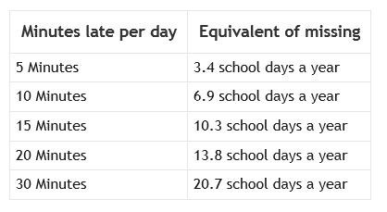
Key Stage 1

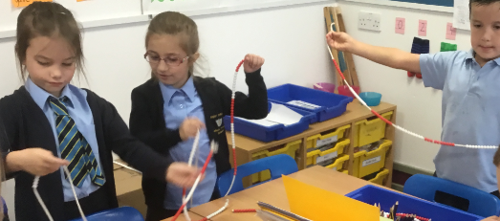

This week year 2s have looked carefully at number patterns. We counted in 2s and noticed that each number has 2, 4, 6, 8 or 0 ones! What patterns have you noticed?

Have a lovely weekend.

Mrs Potterton
dpotterton@maryofthecross.co.uk
Please remember that your ParentPay Account MUST NOT go into debit. Please ensure that you always have sufficient monies within your account at all times. We are continually having to chase debtors which is both costly and time consuming.

Lateness matters
Remember that the school day
starts at 8.50am and that the school is open from 8.30am for early learning.

NEXT WEEK
Tuesday 2nd October
& Wednesday 3rd October

Booking is now open on eSchools for our Parent/Teacher
Consultation Evenings. Remember to sign up for an appointment with your child’s class teacher. This is an important opportunity to find out how your child has started their new academic year and how they

are settling into their new classroom setting. It is also a useful way of finding out how to discuss ways you might support them at home. Your eSchool login will be in the format of: -

Username: first name.surname (e.g. paul.cotter)

Password: This will be the password that you have created.

Please contact the school office if you have any issues with making a booking or if you need a password reminder.

Liturgy in School
Please join us for whole school liturgy on Monday at 9.00 am.
The theme for our prayer and worship this week is:

DO WHAT IS RIGHT

Dear Jesus, help me to use every part of me to bring your love to the people I meet today.

Amen

WHAT’S ON
SOUTH WEST CELEBRATE WEEKEND
A joyful and faith-filled event for all the family!
13th/14th October
Notre Dame School, Looseleigh Lane, Plymouth PL6 5HN
Main Speakers: Maria Heath, Fr. Oscar Ardila, Charles Whitehead
Separate streams for children & young people. Lively worship, drama, a variety of workshops, family Mass
……………………………………….
Online booking now open (Prior booking essential) More details: www.celebrateconference.org Email: southwest@celebrateconference.org Rebecca 01395 489902 or Susanne 01803 606256

Thinking of booking your child into Plymouth Argyle’s Half Term Activity Club? Grab yourself an early bird bargain and use the code above to get 25% off your booking.

IMPORTANT UPDATE
Both the School Disco and the Pizza and Poetry Evening have been postponed. Both will be re-scheduled for after the half-term break. Keep an eye on the list of important dates for future information.

Thank you all for your support as always. Have a wonderful weekend.

Mrs Potterton and Mr Cotter

Here is a list of some

Important dates confirmed
for this year.
All information is available
on our website calendar.

2nd October
Parent/Teacher Consultation Evening

3rd October
Parent/Teacher Consultation Evening

19th October
Non-Pupil day – School closed to pupils

22nd – 26th October
Half Term

29th October
Non-pupil Day – School Closed to Pupils

28th November
Tempest Photography – School Photos

11th December
Christmas Production – 1.30pm & 7pm

12th December
Christmas Production – 7pm

13th December
Christmas Dinner Day

