Holy Cross Primary School

Handwriting and Presentation Policy

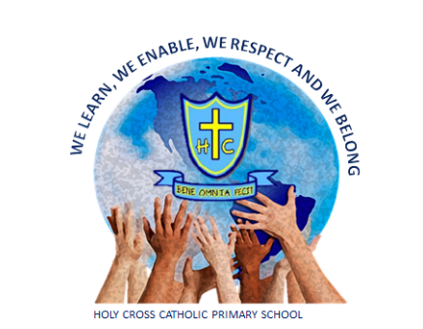

2021

Rationale:
A consistently standard of presentation and handwriting is promoted across the school which all children and staff recognise, understand and follow. For children and teachers this aims to foster a sense of pride and respect in their work.

Presentation across the school:
- All books will display a sticker with the child’s name, subject, class and school logo
- Books for key groups (e.g. pupil premium, SEND, EAL and AMA children) must be demarcated with a coloured sticker on the book label.
- Pupil Premium - orange
- SEND - yellow
- AMA - red
- EAL - green
- All core subject books have ‘Must Have’s’ for presentation displayed on the inside front cover. See Appendix Three
- Every piece of work is dated (long date in all subjects except Maths).
- All work has a Can I … (KS1, where appropriate, can be typed and stuck into books)
- All drawings and diagrams are in pencil.
- Pencil crayons, not felt pens, are used in exercise books.
- Purple pens are used for specific reasons by children e.g. purple pen self –correcting, editing or self and peer assessment.
- One single line is used to cross out mistakes or edit writing.
- Books are well kept with no writing or doodling on the outside or inside of covers.
- Poor presentation is challenged.

Handwriting across the school:

- Children are encouraged to maintain a correct posture and pencil grip.
- Children will be taught letter formation with no lead ins.
- No descenders will be looped.
- Handwriting In EYFS and KS1 is taught through Read Write Inc sessions, with discrete top up’s.
- In all classes there will be at least 1 explicitly taught handwriting session per week https://teachhandwriting.co.uk/ is a good resource to support this
- Where appropriate, in Key Stage 2, handwriting tasks are used to model and practise the correct joined handwriting style.
- Additional handwriting sessions are given to those children whose letter formation, joining or speed require improvement.
- Children write in pencil until the end of year 2
- From year 3 onwards, pupils write in black, erasable pens.
- Fonts for the creation of activity sheets and supporting documents - twinkl unlooped font to be downloaded and used.

See Appendices One and Two

Specific Progression:

Foundation Stage:
- Children are taught correct letter and number formation (with no lead ins), moving from single letters to words and sentences.
- Children are free to select a writing implement of their choice in child initiated learning.
- Correct sitting and pencil grip is taught.
- Fine motor skills are provided to help with pencil grip and control.
- Children are encouraged to write in a straight line from left to right.
- Use of rulers for labelling is modelled by teachers and rulers are available for child initiated learning.
- Some children are taught how to write ‘on the line’ and begin to join some letters (special friends).

Years 1 and 2:
- Children are taught how to join most letters but understand which letters should remain unjoined, maintain regular size and shape of letters and regular spaces between words.
- They develop the fluency of their joined handwriting at word and sentence level.
- Children are all taught to write ‘on the line’.
- They are taught how to underline with a pencil and label neatly with a ruler.

Years 3 and 4:
- Year 3 is the transition time from pencil to pen. By the end of year 3, all children (with exception only for those with a specific weakness with fine motor skills / letter formation) will be writing in pen.
- Until children have been provided with a pen, they are to continue to use pencil in their work books but are taught to use pens in handwriting lessons.
- Children write in black pen (school to provide erasable pens)
- They work on securing joins, improving fluency and continuing spelling links.
- Children are expected and taught how to use a ruler to draw lines, including underlining, diagrams, labelling and crossing out.
- Children write in paragraphs around a theme.
- Children are taught to adapt the layout of their written work to fit the intended purpose, i.e. letter presentation, play script, etc.

Years 5 and 6:
- Children write in black pen (school to provide erasable pens)
- They are expected to use a ruler to draw lines, including underlining, diagrams, labelling and crossing out.
- At this stage, children are learning to develop their own style.
- Children learn to select the most appropriate presentation style for different writing genres.
- They begin to understand the balance between speed and legibility which is dependent on the purpose of the writing: the product or the final draft of a piece of writing.

Inclusion:
These expectations apply to the vast majority of children in our school. Occasionally a decision will be made to personalise expectations for a child who has such specific needs that these expectations could be a barrier to their progress (e.g. a child with physical difficulties writing). Difficulties are addressed through appropriate interventions or specific equipment.

Celebration and Motivation:
All staff ensure that presentation and handwriting is promoted by:

- Celebrating work of a high standard, including homework, in whole class situations. Ensuring good presentation and handwriting is rewarded in line with the whole school behaviour policy
- Using joined, legible and consistently formed handwriting on boards, in books, on flip charts and displays.
- Providing modelled examples and reviewing expectations with children.

Monitoring:
Presentation is monitored by the Senior Leadership Team on a regular basis through work scrutiny, lesson observations and pupil interviews. Feedback will be shared with the class teacher and at Leadership meetings. This will ensure that the policy leads to good practice.

Appendix One

Letter and numeral formation:
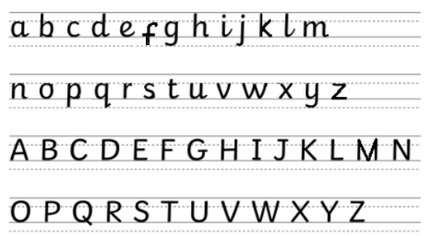
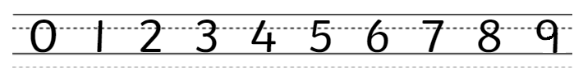
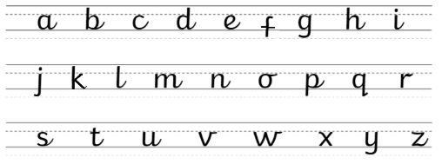

Example:

Appendix Two

Information for books:

EYFS / KS1
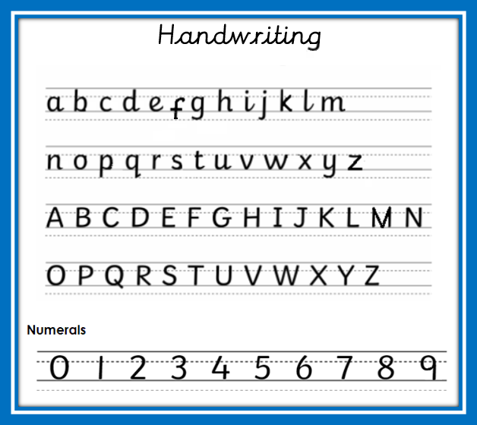

KS2

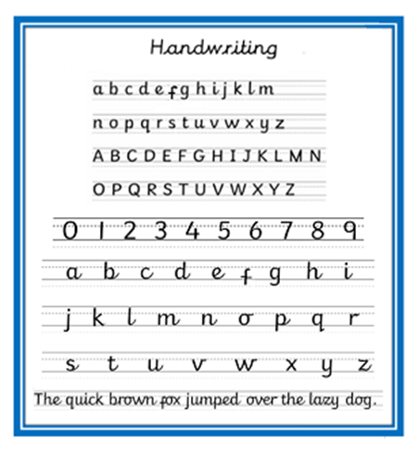

Appendix Three

English - Key Stage One

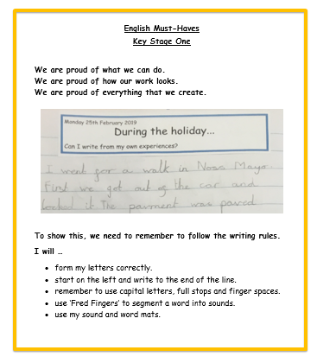

English - Lower Key Stage Two

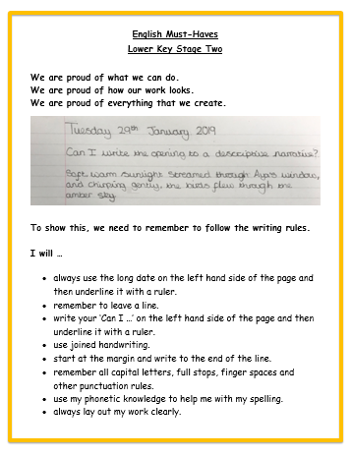

English - Upper Key Stage Two

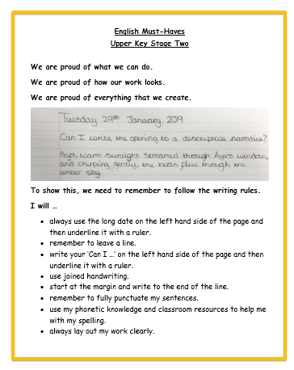

Maths - Key Stage One
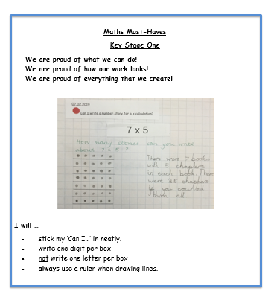

Maths - Key Stage Two

