Message from the Head of Learning

Welcome​ ​back​ ​-​ ​we hope you all enjoyed a happy holiday with your children. We have enjoyed a wonderful first week.​ ​A warm welcome to our new families. You are all part of our lovely Holy Cross family.

Foundation Class meeting
their Year 6 Buddies

We have also welcomed new members of staff to our team this week. Mr Flashman is our new year 5 teacher and Miss Goddard will be teaching in year 5 one day a week. We are delighted that they have joined our wonderful teaching team.

Thank you for sending the children back to school looking so smart. We are proud of our uniform and appreciate your support. Please refer to the policy if you are uncertain about our expectations.

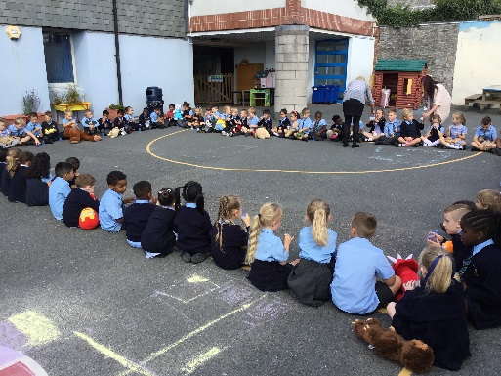

Key Stage 1 Teddy Bears Picnic

The library summer reading challenge closes on September 15th! Hurry along to your local library so that your child can complete the challenge. They will receive a medal and will be awarded a certificate in celebration assembly.

Have a lovely weekend.

Mrs Potterton
dpotterton@holycross.plymouth.sch.uk

Liturgy in School
Please join us for whole school liturgy on Monday at 9.00 am.
The theme for our prayer and worship this week is:

JESUS IS AMAZING!

Jesus, you are brilliant! Thank you for all the wonderful things you do. Thank you for loving us so much.

Amen

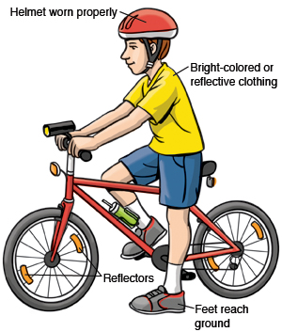

We are pleased to see so many of our pupils here at Holy Cross travelling to and from school by way of either bicycle or scooter. It really is a good way to stay fit

and healthy and a great way to start the school day. Please remember to make sure your child is wearing appropriate safety wear e.g. a helmet and bright reflective clothing to ensure that they stay as safe as they possibly can whilst riding.

Don’t forget that in order to avoid accidents within the school grounds, children are not allowed to ride their bikes or scooters until they are outside of the school gates.

Well done everyone for starting the new school year with a healthy and positive attitude.
Help Needed
Do you share a love of reading?
Do you have some spare time to help us with our school library?
We would very much love to hear from you if you have some spare time and would like to help

with our school library. If you are interested, please visit
Mrs Leach in the School Office who will help you carry out the necessary DBS checks required.

A gentle to reminder to all that ParentPay accounts MUST remain in credit at all times. Accounts that continually remain in arrears, will unfortunately have to be suspended until any balance is cleared, this may result in the school being unable to provide provision for your child where needed. If you are having difficulty making payment, please contact the School Office. If you would like help to set up reminders on your ParentPay account, please visit Mrs Rosevear in the School Office who will be happy to help.
Thank you.
WHAT’S ON

There are lots of fun things going on this Autumn around Plymouth and the surrounding area. For more information visit the Primary Times website https://www.primarytimes.co.uk/plymouth/

Here is a list of some

Important dates confirmed for this year.
All information is available on our website calendar.

2nd October
Parent/Teacher Consultation Evening

3rd October
Parent/Teacher Consultation Evening

4th October
Pizza & Poetry Evening

12th October
School Discos

19th October
Non-Pupil day – SCHOOL CLOSED TO PUPILS

22nd – 26th October
Half Term

28th October
Non-pupil Day – SCHOOL CLOSED TO PUPILS

28th November
Tempest Photography – School Photos

11th December
Christmas Production

12th December
Christmas Production

Thank you all for your support as always. Have a wonderful weekend.

Mrs Potterton and Mr Cotter

