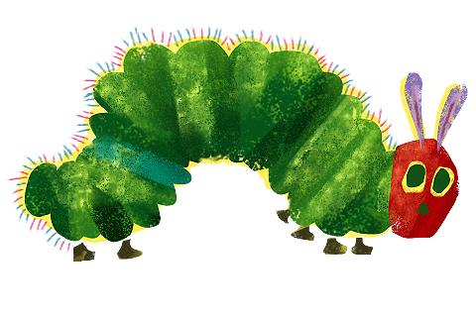

Eric Carle
Mrs King, Mrs Dyson, Mrs Coyte and Mrs Jarvis

Summer Term 2018

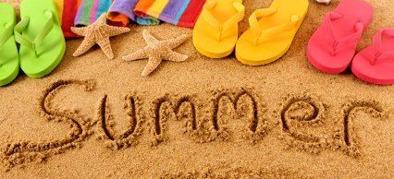

Welcome Back!

We trust that you all had an enjoyable Easter break with your family and
friends and are looking forward to a fun packed summer term!

Useful Dates:

17th April  Month of May  11th-15th June  13th July | KS1 Newquay Zoo Experience  Year 2 SATs testing  HALF TERM  Year 1 Phonics Screening  Summer fair

Things to remember…

- Children are welcome to come into school from 8:30am for a prompt 8:50am start. We provide focused early morning tasks for the children so please arrive as early as possible in order that your child is able to take full advantage of this valuable learning time.

- We have PE throughout the week so please ensure that your full kit is in school every day.

- Reading folders must be in school every day. We will check them every morning for any letters or reply slips being returned. Letters for you will be put in here so please check it every evening for any communications.

- Please continue to listen to your child read as often as you can and make a comment in their reading diary. Children have the opportunity to change their book every day. Many children like to keep their book and read it a few times over. We encourage this practice as it moves children from reading for decoding, through reading with expression and for meaning.

Our focus for the summer term is comprehension so please remember to talk to your child about what they are reading. Ask them to find the evidence on the text to back-up their ideas and opinions too!

- We are outside in all weathers so please provide your child with a waterproof coat every day.

Summer 1 Learning
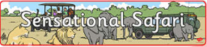

Mathematics
We will begin by the first 2 weeks looking at efficient methods of addition, subtraction, multiplication and division where we will be consolidating the methods we know and discussing when they are best used. Following this we will take a closer look at measuring time, weight and capacity; learning what units we measure in and reading them accurately using marked and unmarked scales.

English
The children will continue with their Read Write Inc. sessions. They have recently been reassessed so their RWI group may well have changed. If you have questions about this please let us know. In class we will develop our reading and writing skills through units based on African animal fact-files, followed by the the story ‘Handa’s Surprise!’.

Topic
Through our geography unit ‘Sensational Safari’ we will learn about the key geographical features of Africa with a focus on Kenya, learning about the wildlife, landscapes and culture. Children will compare Africa to the UK and be encouraged to recognise and respect the similarities and differences.

Science
In this unit children learn about human and animal bodies and consider similarities and differences between them. Then we will take a closer look at life-cycles, focusing on the life cycle of a frog! We have already begun this and the children are very excited!

RE
Our RE unit this term is Easter. During this unit, the children will discuss and further respond to the story of the resurrection and what impact the resurrection had on the lives of ordinary people who witnessed it. The children will explore the events of the first Easter Sunday and find out what we remember during the Easter season.

PE
In PE this term the children will be developing their fundamental movement skills with the aim of learning the basic skills required to take part in a Tag Rugby game at the end of the term. The children will be learning how to dodge, track and intercept as well as learning how to hold and throw a rugby ball.

Summer 2 Learning
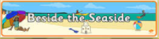
Mathematics
In the summer term we will start with a unit on ‘position and direction’ concentrating on using language to describe position, direction and movement in a straight line and distinguish between rotation as a turn and in terms of right angles for quarter, half and three-quarter turns, both clockwise and anti-clockwise. We will end the term with consolidation of year 1 and 2 objectives so that children are ready for their transfer into year 2 and 3.

English
Daily Read Write Inc. sessions will continue. As well as this, back in class, we will develop our reading and writing skills through an exciting warning tale based the stories based around our theme ‘Beside the Seaside’!

Topic
Our unit ‘Beside the Seaside’ will focus on geographical features of the seaside, both human and physical. Children will learn about seaside environments; finding out where they are located in the United Kingdom and seaside resorts near Plymouth. Children develop their geographical skills through fieldwork, inquiry and map-based activities throughout the lessons in this unit.

Science
In this unit children will learn about a variety of habitats and the plants and animals that live in seaside habitats. They learn to tell the difference between things that are living, dead and things that have never been alive, and apply this in a range of contexts. They make observations of a seaside habitat and the creatures that live there, investigating conditions in local microhabitats and how they affect the minibeasts found within them.

RE
Our RE unit this half term is Pentecost and Mission. This unit invites pupils to deepen their knowledge of the Pentecost story and consider the symbolism of the story. The nature of the promise made by Jesus is a key focus and an understanding of Pentecost as the birthday of the Church is developed. Links are also made between Confirmation and Pentecost. At the end of this half term we will also have a Multi Faith Week where we will focus on the stories of Hinduism.

Useful Information

Home Learning
Compulsory:
Reading:
Please support your child by listening to them read every day and record in your child’s home-school record book. This does not have to be a school book. Don’t forget to read to your child too!

Spelling:
Children will receive spellings at the beginning of the week. Please practise one spelling each night for a test later in the week.

Optional:
Some parents ask how else they may support their child and so we provide some termly challenges that you may wish to try.
To support our parents’ quest to enrich their children’s learning, new Home Learning Challenges will be given out every half term. Each challenge accrues a number of points. Children who earn 100 points per term will be awarded with a certificate. At the end of each term we will hold a home learning presentation session where the children will present their projects to their friends. Thank you in advance for your efforts and support.

Website
Don’t forget to check our class webpage. Each term we will let you know what to expect in the following ½ term. You may wish to use this to support work you are doing with them at home.

Dojos
Our class Dojo site is working well. Children are very motivated by the reward system and feedback reveals that parents are interested in checking in on how their child is getting on. Don’t forget that we also add pictures to the class story and you can message us this way too if you prefer.

And finally…
As always, please contact us if you have any worries, questions or wish to share something new with us! Our door is always open.

Many thanks,
Mrs King, Mrs Dyson, Mrs Coyte and Mrs Jarvis

