Summer Term 2018

**April 16, 2018**

**Dear Parents and Guardians,**

**Happy Easter!**

I hope that you have enjoyed the Easter break and are not too sad to be sending the children back to school!

**Organisation**

Our summer term is always a very busy one where children will be carrying out more formal assessments which will feed into their reports. We’re really trying to focus on writing, spelling and presentation across all areas of the curriculum. In addition to this, having an instant recall of times tables is also key so any support or work on this at home would be fantastic.

This term the children are fortunate to have Mrs Haine and Mr Aqualina for an extended Games session every Tuesday in the MUGA. They will cover my PPA afternoon and ensure the children get quality Games every week.

We are now only one full term away from the children entering Year 6 (a fact that strikes fear into my heart also as my daughter is nearing the end of her Primary Education too) so this year continues to be a crucial time in which we develop many of the skills that will be essential for success in Year 6. We stress again the importance of the children taking ownership of their own learning, including making sure they are prepared for school every day. We ask again that they are responsible for their own homework, letters, jumpers and PE kits. They need to ensure they bring in and take home their reading books daily and that they have the correct PE kit in school at all times.

Homework

We will continue with the project based homework this term around the theme of Rivers. The homework supports and enhances the learning in school. The idea is that the children take ownership and independence with their homework in ensuring it is completed to the best of their ability. It can be emailed to me or there are books for each child to collate it in. I’m happy for children to take resources they need from school to enable them to complete it also. There is a homework club every Monday with me and every Friday after school with Mrs Potterton, so the expectation is that all homework is completed to a minimum of 100 points.

**PE/Games**

PE this term will be all outdoor based to ensure the children have an extended high quality activity session every week. All kits should be in school from Tuesday. As our sessions will mix indoor and outdoor activities a full kit is required. It will be sent home at half term for laundering.

**Trips**

As always, we will be stimulating our learning with off-site activities. I hope to organise two trips over this long term; one to the Aquarium and one to film a documentary about rivers on location.

**Working in partnership**

It was lovely getting to know so many of you last term and we really value the partnership that is needed to provide the best learning experience for your children. As a parent myself, I know the immense trust that you place in us each day as you drop your children into our care and I will work hard every day to honour that trust.

Please continue to take time to say hello or raise any issues at the end of the school day when the children exit school from the red door in the top playground. If you need to speak with me at greater length or privacy, I will naturally be happy to arrange a time to do that.

I *always* welcome any support so please do not hesitate to catch me if you are interested in coming into the classroom to help any time throughout the week.

**Website**

Please regularly check into our Class 5 page on the website where I will post information every term. Also keep checking Dojo as I will update that regularly so you can see what’s been happening in our classroom. I’d also like to direct you to the Maths Zone where there are lots of links and fantastic interactive activities for the children to engage in that will benefit their Maths learning in school.

In **English** we will be continuing to develop as writers by becoming confident story tellers. This term we will be writing ‘Warning’ Tales and ‘Quest’ Stories based on our topic work Raging Rivers and Marvellous Mountains. We will be learning about the features of persuasive and discussion texts within our non-fiction writing work. Our ‘Big Write’ project continues, so watch this space for the talk homework which has been so helpful in generating exciting ideas for the pupils’ independent writing. Our Guided Reading and Read Write Inc. sessions will provide the technical support for the children as writers.

Our **RE** topic is called EASTER and will explore children’s understanding and beliefs around the Resurrection. This will act as a spring board for the children to reflect on their own experiences of God in their lives.

Our **Maths** work will build on the solid progress made last term. We will be developing further confidence in calculation using all four operations. In addition to this, we will be working on 3D shape, angles, lines of symmetry, translation, rotation and reflection and looking at time and coordinates.

Our **Science** investigations will focus on Electricity and Scientists and Inventors. We do begin to look at Reproduction and will cover this in more detail after the half term, where we will be inviting the school nurse in to talk to the boys and girls separately.

Our **Foundation Subjects** (IT, Geography, History, Art, and DT) will be covered as part of our ‘Raging Rivers and Marvellous Mountains’ topics which last for the whole term. PE will outdoor based focusing on Athletics, ready for Brickfields and Sports Day next term and Kwik Cricket.

All of our learning is underpinned by the **Personal, Social, Health and Emotional** work the pupils engage in. This term they will be considering how to set and achieve goals and the importance of high self-esteem.

As this term is only 6 weeks we will have to ‘hit the ground running’. There will be some Big Write prompts coming home next week and I would be very grateful for your support with these. Also, all children are logged onto Times Tables Rockstars, which is a fun way to embed their tables. Any support with your children accessing this would also be brilliant.

With every good wish,

Rachael Riley

**our Learning this term…**

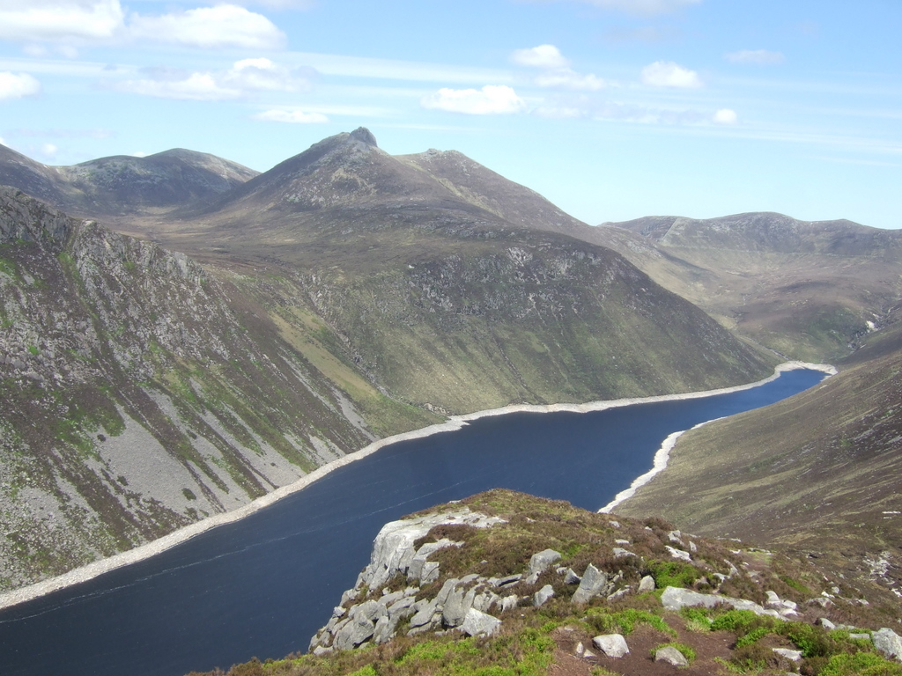



[](http://www.google.co.uk/url?q=http://www.numberwatch.co.uk/&sa=U&ei=CwdHU_7VDcqVhQfS1oHwAQ&ved=0CC4Q9QEwAA&usg=AFQjCNEWWYU0sta9uE4D-SMhSzGCCc3BnQ) [http://t2.gstatic.com/images?q=tbn:ANd9GcRMCy3nPRlaqMHisYbdVtgDQwVKChT1f8zqnXwIgudMH8Tm6FxLqDDNXVoY](http://www.google.co.uk/url?q=http://www.sullyschool.co.uk/big-write/&sa=U&ei=TQdHU6WIMIi0hAe3oIHABw&ved=0CDAQ9QEwAQ&usg=AFQjCNHcXcU257rmiuO-6LCAtT1CmiDMCg)