MESSAGE FROM THE HEAD OF LEARNING
The end of another school year - this is a special time to look back at all the happy moments we have shared at Holy Cross this year. The children have enjoyed celebrating the year in class and in our final celebration assembly. They are all ready for a well deserved holiday!
Goodbye and thank you - we are sorry to say goodbye to Mrs Hardwick and Mrs Maroney today. They have both brought so much to our school community.
We are grateful to Mrs Maroney for her commitment to the children in her care. She ensured that their final term in year 4 was packed full of engaging activities and high quality learning. We wish her every success.
Mrs Hardwick has made a huge impact in her time at Holy Cross. Under her leadership, RE has been outstanding. Her influence will continue to motivate and inspire us long after she has taken up her new role. We wish her well.
School Parliament - Mrs Confue and I were very proud to accompany our School Parliament on their visit to the Council House earlier this week. We were delighted to meet the Lord Mayor. She noted the children’s beautiful behaviour and their interesting questions. They looked completely at home in the Council Chamber!
This year’s books - the children are rightly proud of the work they have produced this year. We need to hold on to their books until the end of the Autumn term so that we have evidence of their achievements. I am sure you will look forward to having your

children’s books to treasure for many years.
Summer reading challenge - don’t forget to take your child to the library to sign up for the summer reading challenge. They need to read six books by September. Reading will be a huge focus for us as a school next year - let’s make a start now!
H.C.P.T - Group 45 - a big THANK YOU to everyone who supported our stall at the Summer Fair. We made £200.00. Thank you to all who contributed towards the total. A big THANK YOU to Carmen and Marisa who spent all afternoon selling toys.
Meet the teacher event - you are invited to meet your child’s new class teacher at 3.30pm on Monday 11th September (Years 1 and 2), Tuesday 12th September (Years 3 and 4) and Thursday 14th September (Years 5 and 6). This is the perfect opportunity to find out what the children will be learning and about how your child’s new class runs. There will be time to ask questions. We are looking to arrange childcare provision for those wishing to bring their children along. We will update you further in due course.
In October we will be providing an update about your child’s attainment and progress, including information about targets. This is in response to your request for more information.

And finally...thank you all for your support this year. We are fortunate to have such an interested and engaged community of parents - your ideas and opinions are invaluable. The staff are very grateful for your support. We wish you a happy summer with your children. See you all again on September 4th!

Mrs Potterton
dpotterton@holycross.plymouth.sch.uk

LITURGY IN SCHOOL
Next term, parents and parishioners are invited to join us for liturgy, 9am, Monday mornings.

God of wisdom, we thank you for all the gifts you have given us throughout this school year. As we come to the end of this school year, we voice our gratitude for the good things you have done in us, and we praise you for all who have shared in the work of this school. We ask you to bless them in your love and give them refreshment and peace.
Amen

On time Heroes

Being at school on time is crucial for learning. Our On Time Heroes this week are:

Year 4

Well Done everyone!

Winners of Holy Cross’ Got Talent 2017 were:

Alvin Bromeo and Elijah Adesanwo (KS1)

Lily Grimes, George Stallard, Adriana Emou and Ruby Dunstan (KS2)

Congratulations to you all!

Wonder of the Year Awards

Elsie and Alvin (FS)
Annie (Maple)
Alice (Holly)
Yashvee (Oak)
Amelia (Y3)
Martyna (Y4)
Erin (Y5)
Bede (Y6)

Year 6 Stars

Alternative
Endeavour - Lara

Hopes & Dreams - Alan

Excellence - Samarth

Progress - Molly

Spirit of Holy Cross -
Isabel and Joshua

George Widgery for
Service – William

Dates for your Diary

Here are a list of some important dates confirmed for next term. All information is available on our website calendar.

Friday 1st September – Non-Pupil Day
Monday 4th September - First Day of Autumn Term

What’s On…..
ED’S BIG SUMMER FOOD TOUR#3:

Coming to an open space near you soon!

Every Tuesday and Thursday through the month of August we will be delivering 300 freshly prepared bagged healthy
meals across Plymouth from 12 noon – 2.00 p.m. but when they’re gone, they’re gone! Supported by Radio Plymouth we will be offering face painting on Tuesday and Thursday and getting together some fun activities for the kids as well.
LUNCH AT THE LIBRARY: This year we’ve joined forces with Plymouth Libraries so every Wednesday we’ll be supporting the Summer Reading Challenge and delivering 200 lunches to three libraries to fit in with their
full day of amazing free activities to keep the kids entertained all day and some special guests. Ed will also be making a special appearance! An exciting time planned so come and enjoy the fun. It’s FREE!

DATES AND PLACES TO FIND
THIS SUMMER BETWEEN 12 – 2.00 p.m.:

Tues 01 August CENTRAL PARK PLAY PARK (by the clock, opposite The Life Centre)
Wed 02 August LUNCH AT THE LIBRARY: St Budeaux Library, Devonport Library & 4
Greens, Whitleigh Hub pop up library.
Thurs 03 August DEVONPORT PARK Devonport
Tues 08 August THE BROADWAY Plymstock

Wed 09 August LUNCH AT THE LIBRARY: St Budeaux Library, Devonport Library & 4
Greens, Whitleigh Hub pop up library.
Thurs 10 August ST LEVAN’S PLAY PARK (College Road Primary School), St Levan’s
Road.
Tues 15 August PLACE DE BREST City Centre – with the Radio Plymouth bus & Central
Library Team
Wed 16 August LUNCH AT THE LIBRARY: St Budeaux Library, Devonport Library & 4
Greens, Whitleigh Hub pop up library
Thurs 17 August VICTORIA PARK Millbridge
Tues 22 August KELLY CLOSE Barne Barton – linking directly with the Play Rangers
Wed 23 August LUNCH AT THE LIBRARY: St Budeaux Library, Devonport Library & 4
Greens, Whitleigh Hub pop up library
Thurs 24 August ASDA Estover
Tues 29 August FREEDOM FIELDS PARK Lipson
Wed 30 August LUNCH AT THE LIBRARY: St Budeaux Library, Devonport Library & 4
Greens, Whitleigh Hub pop up library
Thurs 31 August CENTRAL PARK PLAY PARK (by the clock, opposite The Life Centre)

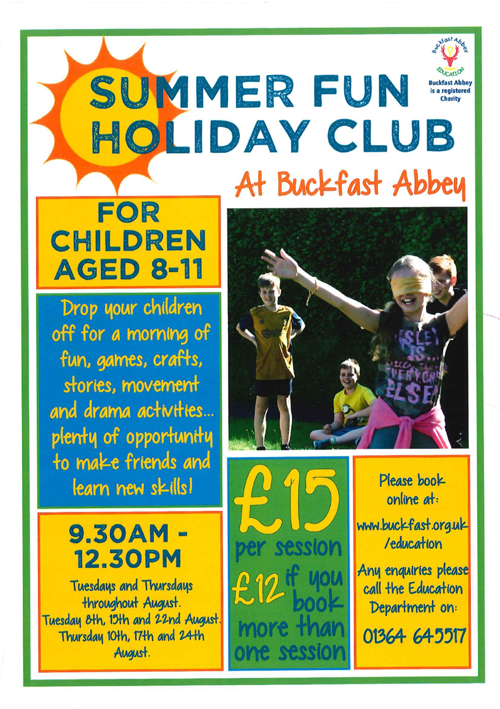

Buckfast Abbey Education are running a holiday club throughout August. for more information visit www.buckfast.org.uk/
education or call 01364-645517

After School Clubs

From September Plymouth Argyle Trust who run the after school football and rugby clubs will only be accepting payments online: they will no longer accept cheque or cash. To be able to pay for the clubs starting in September, please type the link below into your computer
https://argylecommunitytrust.co.uk/courses/holy-cross-school-club
and select the club you require and follow the payment details. Any questions please speak to the office.

We will let you know about clubs in the new academic year in September. However, keep an eye on the Premier Sport website www.premiersports.org as they will place all information on there. We will however send you a text when you are able to book places.

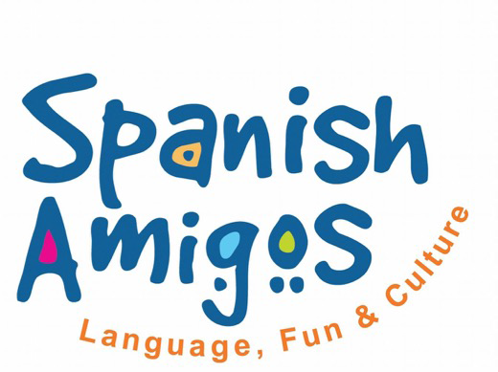
Fun and interactive
Spanish club starting in September!
Just £32.50 per child for a 5 week term (£6.50 per class)
Foundation to year 2: Thursdays 3:30 – 4:30pm (14th September to the 12th October)
Year 3 to year 6: Fridays 3:30 – 4:30pm (Friday - 15th September to the 13th October)
Visit: www.spanishamigos.co.uk for more information.
Email:Plymouth@spanishamigos.co.uk to
confirm the payment with:

- Full Name of Student.
- Age
- Class/year
- Food Allergies
- Special
- needs
- Name of Responsible Adult
- Emergency phone number

ONLINE PAYMENTS:
Spanish Amigos Plymouth
Branch sort code:
30-96-68
Account Number:
86169460
Ref: HC+ Name of Student

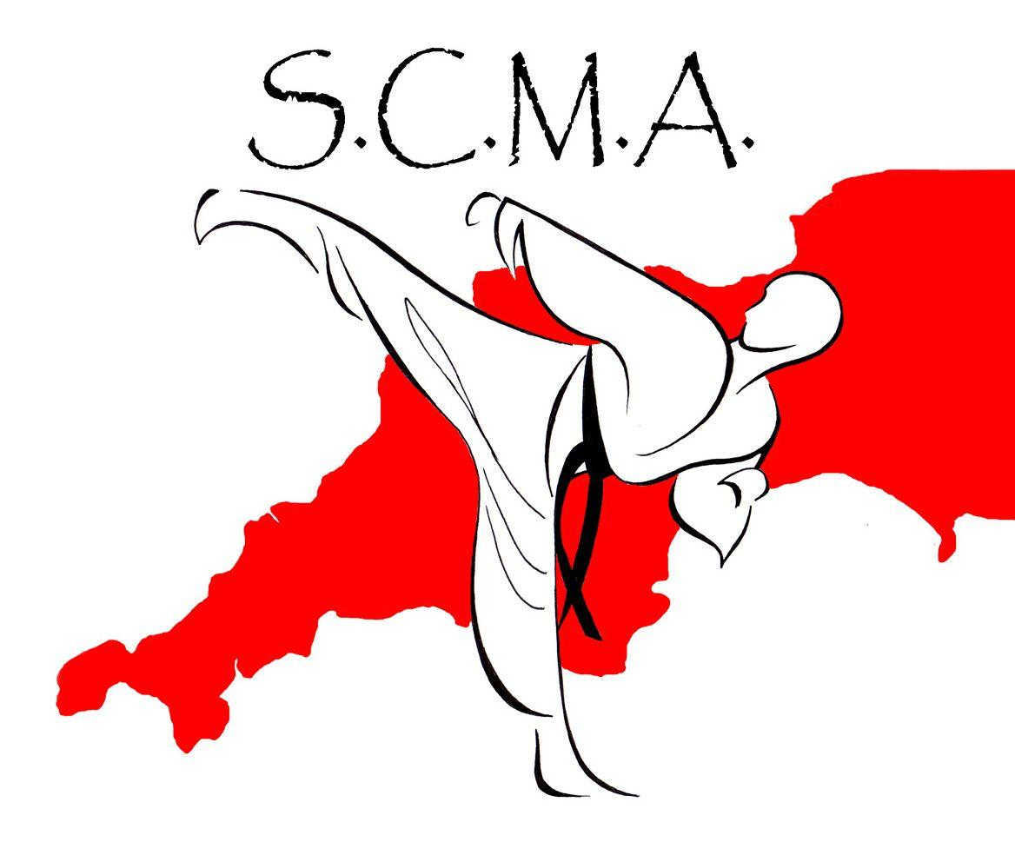

South Coast Martial Arts has great pleasure in offering an afterschool club to our school starting in September. The club will commence on Monday 11th September and will run from 3.15pm to 4.15pm. The cost for the

course is £15.00 payable by 8th September into the following bank account:
South Coast Martial Arts Sort Code: 30-98-46
Account No: 31584460. A form will need to be completed prior to the commencement of the course. If you are interested in joining the club, please collect a form from the school office.

School Dinners
After School Club
& Breakfast Club

We have spent a considerable amount of time this week chasing for debtors which is very time consuming. Please can you ensure your account has been cleared. Please remember that your ParentPay account is to remain in credit at all times. Your co-operation would be very much appreciated. If you are having trouble paying, please contact the school office.

An end of year message from the……...

With another school year over, the Holy Cross Catholic School PTFA would like to say a few words. First and foremost we would like to wish a fond farewell to each of the pupils leaving us this year and wish them every happiness at their chosen new schools.

We would also like to say a big thank you to everyone who joined us for the Summer Fair. We all had fabulous fun and were pleased that so many of you could join us in what was a lovely atmosphere. A huge thank you to all of the volunteers and staff who helped make the Fair a success. Together we made in the region of £1,000 profit - so well done!
.
The PTFA are already busy planning events such as discos and mufti days for next term. If you would like to join us (you can help as little or as much as you wish) you would be very welcome.

Finally, we hope you all

have a wonderful summer holiday break and look forward to seeing you in the Autumn Term..

Holy Cross PTFA Team.

Edenred ref - P21102440
Fideliti ref - HOL357C
Allsave/Sodexo/p&mm/salary plus ref – 872743
Computershare ref – 0024415526

Thank you all for your support as always and have a lovely Summer.

Mrs Potterton and Mr Cotter

