Children’s
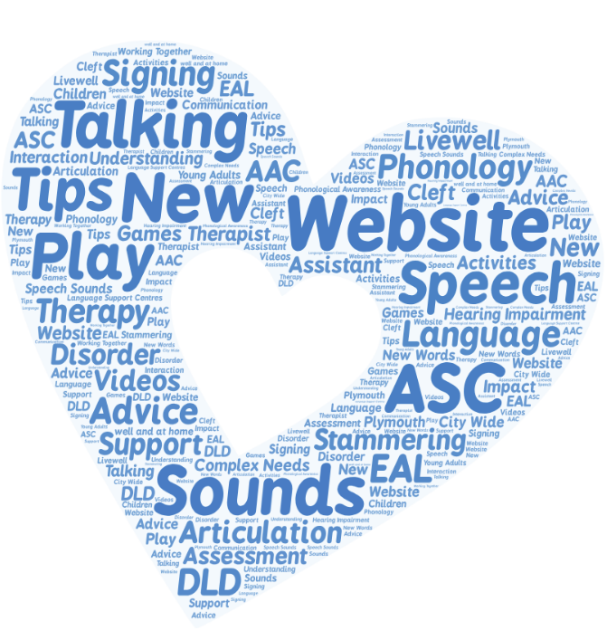
Speech and Language Service

For Information, tips and advice on all things speech and language
Visit our new website at:
https://padlet.com/Livewell/speechlanguage
Children’s
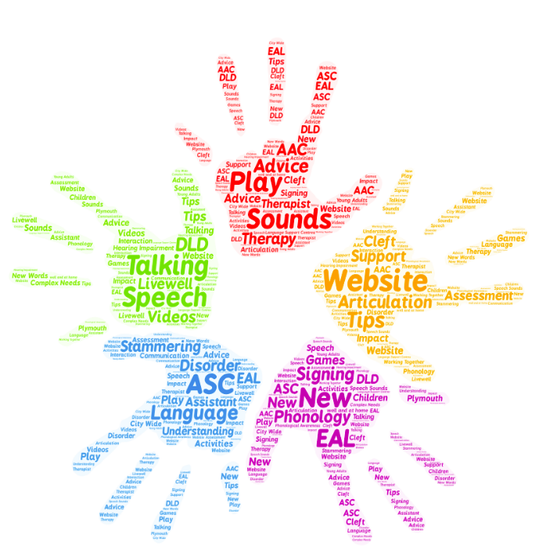
Speech and Language Service

For Information, tips and advice on all things speech and language
Visit our new website at:
https://padlet.com/Livewell/speechlanguage

