Welcome back. We hope you all had a lovely Easter break!

Topics for the Summer term
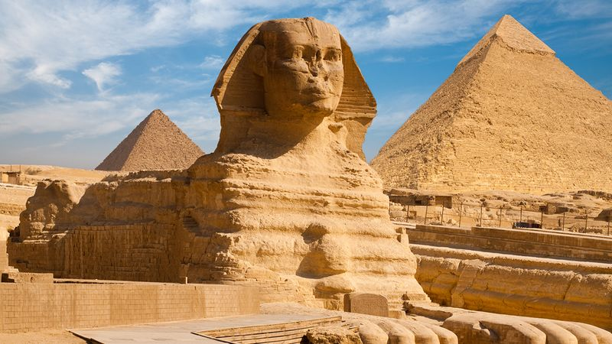

Our topic for the whole of the Summer term is ‘Ancient Egypt.’ We will be looking in depth at the achievements of this ancient civilisation. The children will learn about how and where the ancient Egyptians lived, what was important in the daily lives of ancient Egyptians, who Tutankhamun was and how mummies were made. The children will also learn about how Egyptian people used hieroglyphics to communicate and compare the powers of different gods. In English, for the first half term we will be writing wishing tales based on ‘The Egyptian Cinderella’. After this, we will be writing recounts and newspaper reports about King Tutankhamun. For the second half term we will be writing scary stories based on ‘The Mummy’s Curse’. Finally, we will be writing information texts based on ‘How to Defeat a Monster’. Mathematics will cover investigating statistics, visualising shape and exploring change in the first term and proportional reasoning, describing position and measuring and estimating in the second half term. Art will link to our topic as we will be making Egyptian masks. Our RE work will start with Easter followed by Pentecost. We will have half an hour weekly French lessons.

In science, for the first half term we will be focusing on how vibrations cause sounds and how sounds travel, as well as how sounds can change pitch and loudness. The children will also learn about how sounds are made, carrying out demonstrations of vibrations, and completing a sound survey of our school.

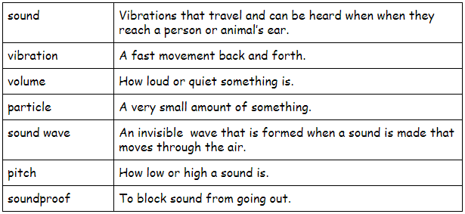

In science, for the second half term we will be focusing on forces and magnets. We will be looking at forces including friction and magnetic attraction. The children will be learning about forces in the context of pushing and pulling, and will identify different actions as pushes or pulls. The children will work scientifically to investigate friction, by exploring the movement of a toy car over different surfaces.

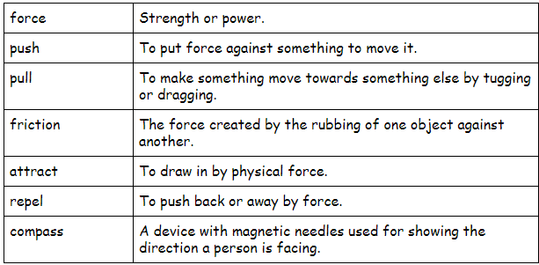

Key vocabulary for Ancient Egypt

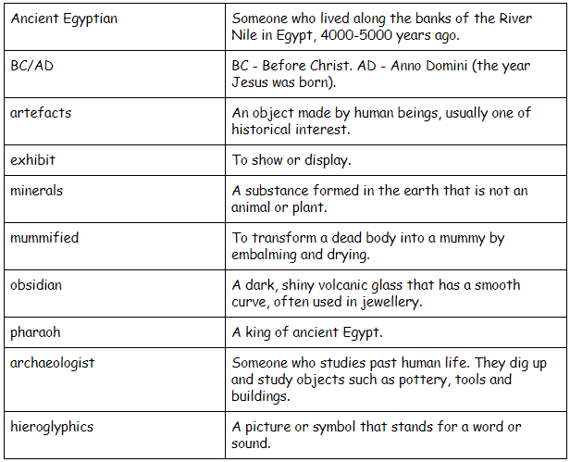
Things to remember to bring into school:

Home learning
Reading folder
Reading record
PE kit
Waterproof coat
Water bottle
Lunch (or ensure that your ParentPay account is topped up)

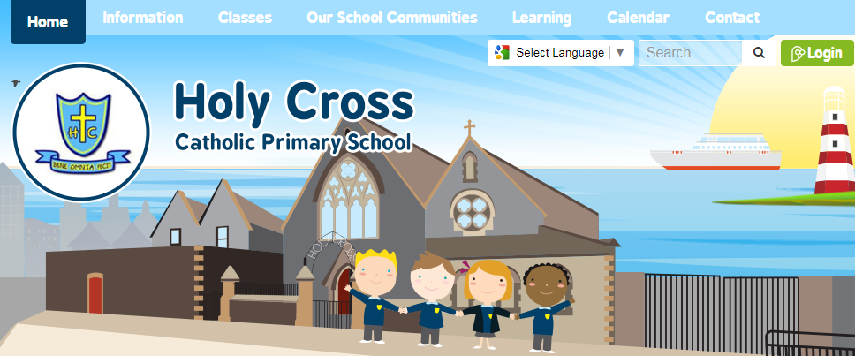

School website
On our school website each class has their own selection of web pages. There are class galleries, home learning pages, learning resources and downloadable copies of letters that have been sent home.
There are also some lovely subject area zones under the learning tab at the top of the webpage.

Contacting your child’s teacher
Please feel free to always talk to us at the end of the day when you pick up your child. Sometimes, we appreciate that this may be difficult so please feel free to email us:
Miss Bailey: bbailey@holycross.plymouth.sch.uk
Miss Cairns: acairns@holycross.plymouth.sch.uk
Miss Mooney: smooney@holycross.plymouth.sch.uk

Ways to help at home

Reading - Time spent listening to your child reading is so valuable. It not only benefits them in terms of you helping them with comprehension, fluency and word recognition, but it also teaches them that reading is something that you can enjoy with others.
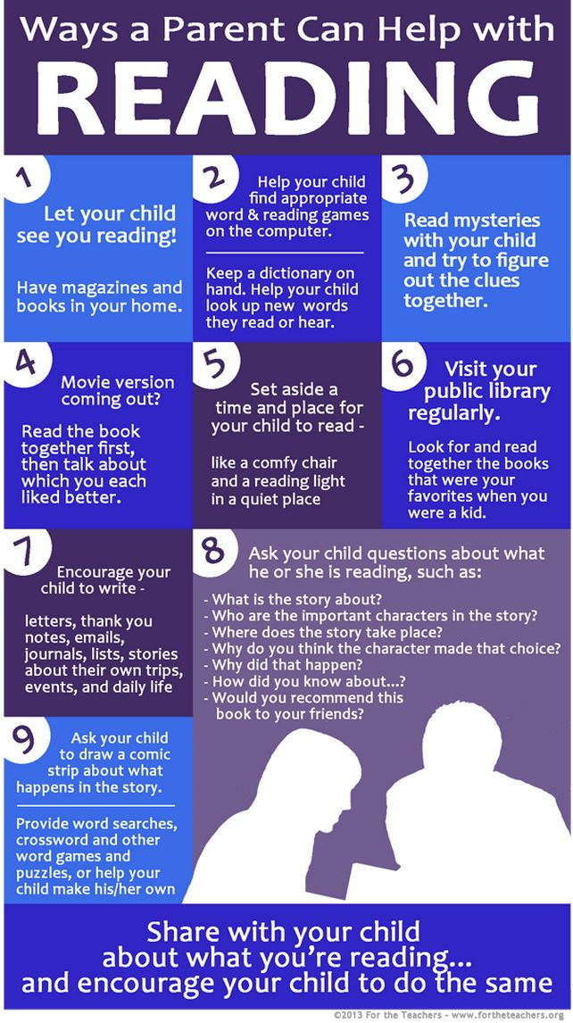
Maths - play games involving dice and encourage children to count and look for patterns, encourage children to show you methods they have been learning in school, ask children to help you measure things at home (could be for a recipe or using a tape measure etc.) and ask them LOTS of questions:
Which is bigger? Which is smaller? Which do you think weighs more? How many minutes until..? What time is it? I have ‘x’ amount of money. Can I buy ‘this’ and ‘that’? What shapes can you see? How do you know it is that shape? Why is 3 x 4 more than 2 x 4? Can you help me measure this? What did you learn in school today? Can you show me which method you used? How does it work?

