Holy Cross Primary School – PE and Primary Sports Funding 2015 / 2016 Review

2015/16 has been a fantastic year for Holy Cross Primary School, full of sporting achievements and brilliant Physical Education provision. We have undertaken a number of child, parent and staff surveys throughout the year, which highlighted a number of critical areas for development.
First and foremost, there was a strong sense that the school lacked extra-curricular sporting opportunities. In the 2014/15 year, only 11% of children were involved in a club, most of whom were in KS2. This year, we have developed partnerships with a range of providers which has led to a rise in club participation from 11% to over 65%! At our peak in the summer terms, we were able to offer 11 different sporting clubs a week accessible to every age group.
The next priority that arose as a result of the surveys was the sporting prowess of Holy Cross. Everyone wanted our school to be recognised as a strong sports school which utilised some of the incredible talents that some of our students possess. In recognition of this, we have competed 15 events across a range of age ranges and abilities including A, B and C teams all of whom finished strongly. This resulted in 4 different teams ( Y 5/6 Tag Rugby, Y3/4 Tri Golf A, B and C teams) making it through to the regional finals at the Devon School Games in Exeter, an amazing achievement!
Finally we are now the very proud owners of the School Games Kitemark Gold Award. This is a nationally recognised standard in sport provision. The staff, children, parents and PE team have worked incredibly hard to achieve this standard which really is something that we can all take pride in.

What is this funding and what is its purpose?
The government is providing funding to improve provision of Physical Education and sport in primary schools.
The funding, provided jointly by the Department of Education, Health and Culture, Media and Sport for our school amounts to around £9000.
This funding is ring-fenced for the sole purpose of improving the provision of our delivery and the children’s enjoyment of sport throughout the school.
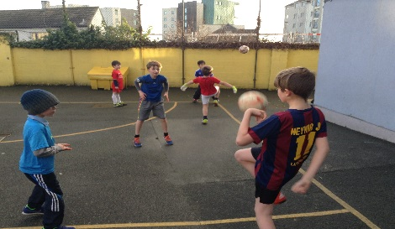
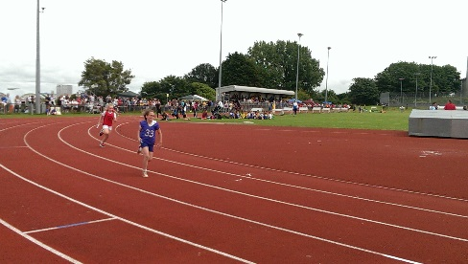
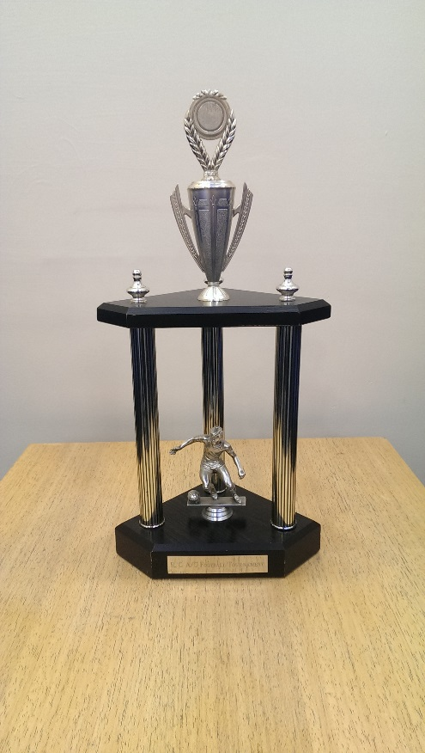

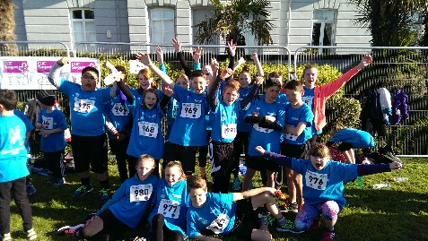
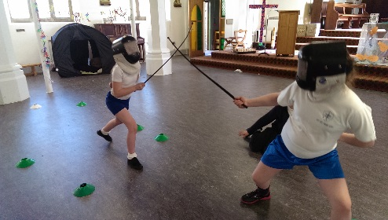

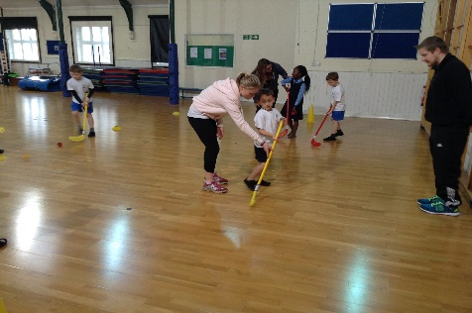
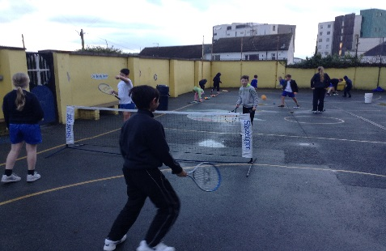

What did we use our funding for?
As part of the Mary of The Cross Federation, Holy Cross School is committed to providing opportunities to develop of the whole child. It is important to us that our children are encouraged to live healthy, active lifestyles, they enjoy and participate in physical activity, they develop the, confidence skills and attributes associated with good sportsmanship and leadership as well as be given opportunities to engage in competitive sport and coaching. We are proud of our dynamic and varied school spirit and would like to promote and celebrate our community through sport. Below is a breakdown of how we spent our funding for the 2015/16 year;
- Being a member of the ‘Plymouth Schools Sports Partnership which includes;
  - Full Plymouth SSP ‘Core Offer’ including Bikeability, Coaching Days, access to Citywide Competitions, website membership, MTA and Play Leader Training etc.
  - Specialist Partnership PE Teachers (formerly PE Release Teachers) to work alongside primary teachers when teaching PE (regular visits, at least once every half-term).
  - Specialist Partnership PE Teachers to set-up and deliver Change4Life sports clubs
  - Professional development opportunities in PE/sport
  - ‘Family’ run sport competitions (at least one per half-term) to engage in competitive sports and activities in line with the new National Curriculum
  - Providing quality assured professional development courses and materials for PE/sport
  - Providing leaders to support after school sport clubs
  - Working towards achieving the Sainsbury’s School Games Gold Award
COST £3,500
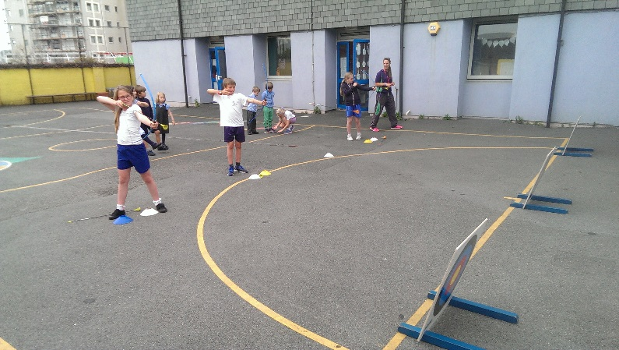
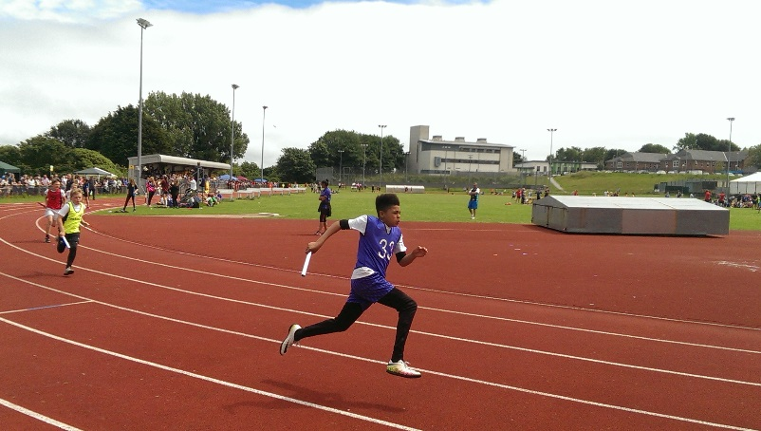

- Developing our clubs provision as well as running more sports competitions and increasing participation in inter and intra school games.
- We ensured that every class had access to at least one Inter School event, for instance, the Year 3 and 4 children went to the Golf Tournament, the Year 5 children represented the school in the Cross Country and the Year 1 children went to the KS1 Indoor Athletics. We ensured that no willing children were discounted through the creation of B and C teams who then competed alongside their peers. We also worked closely with Plymouth University to provide opportunities for the Foundation children to take part in intra school events. The year culminated in an event that utilised our Academy ties with Notre Dame Secondary School who ran a fantastic sports day.

- Supporting and engaging pupils who are least active and providing funding so they can attend more school sports clubs and activities.
- In order to best support least active pupils, it was first apparent that we needed to expand the range of clubs that were on offer to them. We have built strong links with several sporting establishments, all of whom have taken part in providing additional extra-curricular sports activities including football, tag rugby, tennis and golf. Many of these clubs offered free taster sessions and we were able to subsidise them for all children to make them open to a wider audience. We have worked closely with PremierSport.org who have provided a wealth of less mainstream clubs such as Archery, La Crosse, Indoor Curling and Cheerleading all of which we were able to subsidise for the benefit of all.
COST £2,000
- Hiring specialists: First for Sport who provide skilled PPA cover and extra-curricular clubs in a range of sports and dance activities.
- This was not deemed a worthwhile use of the money as we felt that by bringing in specialists, we would be down skilling our own staff. Instead, as a result of staff surveys, the school bought into a PE planning scheme that allowed them to build lessons across a range of skills with confidence. This has been very successful and will be continued from now on.
COST £110
- Buying resources and equipment to develop sports provision and development of the PE curriculum.
- With the development of our new hall, a large quantity of the budget was allocated to buying new equipment to ensure that the space could be utilised effectively. This included indoor balls, mats and gym equipment. We also needed to update broken and damaged equipment.
COST £2,000
In addition to this spending, some of the sports funding was also used for transporting children to and from events, including gestures of goodwill to adults who gave up their own time to drive the minibus to and from events. We also used some funding for the purchase of medals and trophies to encourage children and raise the profile of PE throughout the school. Further money was spent on booking fees for tournaments outside of the PSSP.
As we have access to the Federation Minibus, the decision was made to use some of the PE funding to help cover the running costs. As a school, we used the minibus frequently to transport children to and from events around the city and further afield. We still find it difficult to secure drivers for the minibus which has led to a number of last minute taxis etc. In order to improve PE further next year, it will be necessary to ensure that new drivers are either trained or recruited.
Finally, the decision was made to use some of the funding to support families who regularly participate in sporting events outside of school, such as national tournaments. We have supported some of our wonderful children who have gone on to compete at a county and national level. We like to ensure that where possible, we show our support of their participation in some way to help the children continue on their sporting journey and giving them the chance to build upon these experiences.

We have also ring-fenced some of the funding to help us to continue to subsidise the cost of clubs next year.

Our total spend for the 2015/16 year was £11,500. The additional funds were a result of an underspend from the previous year.
