Message from the
Head of Schools

We were delighted that so many of you were able to meet with your child’s class teacher this week. There will be another formal parent-teacher evening later in the year but, in the meantime, do remember that the teaching staff are available to meet with parents throughout the year. Appointments may be made through the school office.

We received the wonderful news last week that Holy Cross achieved the highest proportion of children completing the Mischief Makers Summer Reading Challenge this year! 79 children (30% of pupil roll) will be awarded certificates in a special celebration assembly next Friday. Their combined efforts have earned us the school prize of £100 to be spent on books. Well done to each and every one of them. Thank you for supporting your children to become readers for life.

Next week, the libraries are launching a year round challenge ‘Findalots’ for all children aged 4-11, so you don’t have to wait until next summer to take part! Please take your child along to sign up:
https://www.plymouth.gov.uk/libraries/childrenandyoungpeople/findalotslibrarychallenge

Our Harvest Mass has been rescheduled for Sunday 14th October at 10.00am. We are looking forward to celebrating as a whole school community with our parish at the Cathedral.

Mrs Potterton
dpotterton@maryofthecross.co.uk

Liturgy in School
Please join us for whole school liturgy on Monday at 9.00 am.
Please remember that your ParentPay Account MUST NOT go into debit. Please ensure that you always have sufficient monies within your account at all times. We are continually having to chase debtors which is both costly and time consuming.
The theme for our prayer and worship this week is:

GOD LOVES US
Dear Jesus, please help all the people who are married to stay friends with each other always. Sometimes people can’t stay married. Please help them to know that God’s love for them will never end.
Amen

Lateness matters
Remember that the school day
starts at 8.50am and that the school is open from 8.30am for early learning.

WHAT’S ON
SOUTH WEST CELEBRATE WEEKEND
A joyful and faith-filled event for all the family!
13th/14th October
Notre Dame School, Looseleigh Lane, Plymouth PL6 5HN
Main Speakers: Maria Heath, Fr. Oscar Ardila, Charles Whitehead
Separate streams for children & young people. Lively worship, drama, a variety of workshops, family Mass
Online booking now open (Prior booking essential) More details: www.celebrateconference.org Email: southwest@celebrateconference.org Rebecca 01395 489902 or Susanne 01803 606256

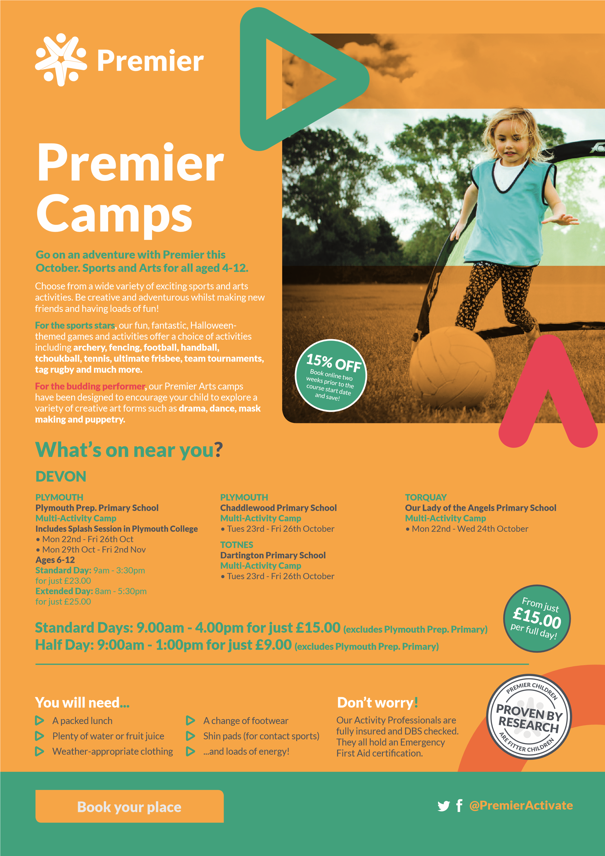

Thinking of booking your child into Plymouth Argyle’s Half Term Activity Club? Grab yourself an early bird bargain and use the code above to get 25% off your booking.

Thank you all for your support as always. Have a wonderful weekend.

Mrs Potterton and Mr Cotter

Here is a list of some

Important dates confirmed
for this year.
All information is available
on our website calendar.

19th October
Non-Pupil day – School closed to pupils

22nd – 26th October
Half Term

29th October
Non-pupil Day – School Closed to Pupils

20th November
Tempest Photography – School Photos – NEW DATE

23rd November
School Discos – NEW DATE

11th December
Christmas Production – 1.30pm & 7pm

12th December
Christmas Production – 7pm

13th December
Christmas Dinner Day

