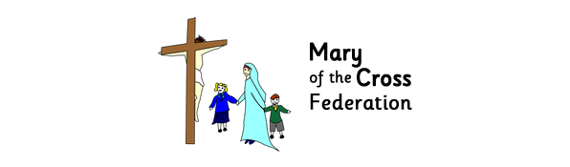
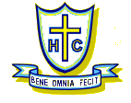

HOLY CROSS CATHOLIC PRIMARY SCHOOL
Headteacher
Mr P. Cotter B.Ed

2 Beaumont Road, St Judes, Plymouth, PL4 9BE Tel: 01752 225420 Fax: 01752 252293
E. Mail holy.cross.rc.primary.school@plymouth.gov.uk Web site: www.holycross.plymouth.sch.uk

Thursday 28th September 2017

Dear Parents and Carers,

We are very excited to be able to tell you that we have secured a visit from our Year 1 class author, Simon James, on Tuesday 3rd October to work with year 1, 2, 3 and 4.

We are really excited about the visit which promises to be an inspiring morning for all of the children. Children will be sharing his wonderful stories and taking part in an hour long workshop.

If you wish to purchase one of Simon James’ books, children may bring £5.99 or £6.99 to school with them on Tuesday 3rd October. Please ensure that money is in an envelope, clearly stating your child’s full name and class. Simon will sign and draw a picture in each book purchased for children to take home and enjoy.

If you have any questions please do not hesitate to ask.

Kind regards,
Miss Heaton

