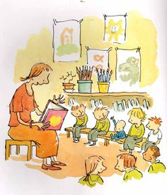

Simon James Class
Miss Heaton and Mrs Jarvis

Autumn Term 2017
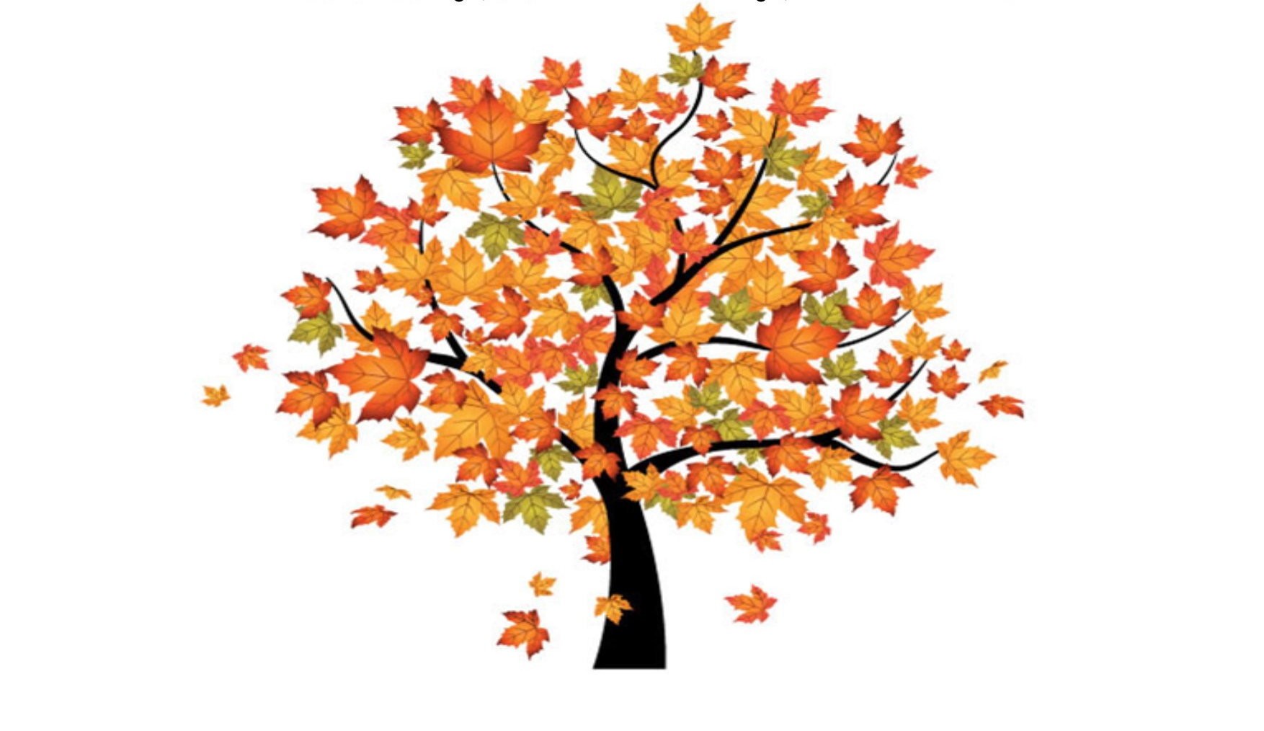

Things to remember for school… 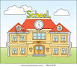

- Children are welcome to come into school from 8:30am. This allows the children time to put away their belongings, change their reading books, osettle in and begin the school day promptly at 8:50am.

- Please collect your child at 3:15pm from the lower playground by the main entrance.

- We have PE throughout the week so please ensure that your full kit is in school every day.

- Reading Folders must be in school every day. We will check them every morning for any letters or reply slips being returned. Letters for you will be put in here so please check it every evening for any communications.

- Please listen to your child read as often as you can and make a comment in their Reading Diary. Books will be changed once you indicate in the Reading Diary that the book has been completed.
Mrs Jarvis tracks the children’s reading journey and rewards each child with a small prize and certificate each time they reach 10 reads. Please support your child by providing some quiet time to read every day and record their achievements in the reading log.

- You can provide a named water bottle for your child. We will return these each day to be washed and re-filled.

- We are outside in all weathers so please provide your child with a waterproof coat every day.

Autumn Term Learning
Autumn 1

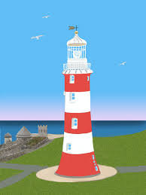

Mathematics
Our first half term’s learning will be based around number and place value. We will be writing, representing and spotting patterns when working with numbers 0-10, 0-20 and then 0-100.

English
The children will partake in Read Write Inc. sessions with children on a similar ability. These focused learning sessions will develop phonics reading and writing skills. In class we will develop our reading and writing skills through units based on the ‘special bags’ we made about ourselves over the summer holiday and then move onto learning the ‘Lighthouse Keeper’s Lunch’ to link to our topic.

Topic
Our geography based topic this term is ‘Our Local Area’. We will be learning about the physical and human features of our locality, begin to read maps and plot routes using positional language. Then we will look at different types of houses in our locality. Our topic will begin next week with a trip to the Hoe and climbing the Lighthouse! We have also managed to secure a visit from the talented artist Brain Pollard! He will show us his work and then we will have a go at painting in his style.

Science
We will focus our learning this term on Plants by looking at naming parts of a plant and looking at the life cycle of a plant.

RE
In RE will be developing our appreciation of ourselves and the world around us as part of God’s creation. Following that, we will begin a unit on Sacraments where we will explore what happens during Baptism, Matrimony and the Eucharist.

PE
We will be developing games skills through a unit on hockey.
Autumn Term Learning
Autumn 2

Mathematics
In Autumn 2 we will focus on calculating numbers by developing our written and mental strategies when adding and subtracting. We will then move on to shape where we will name, describe 2D and 3D shapes using mathematical terminology.

English
Daily Read Write Inc. sessions will continue. As well as this, back in class, we will develop our reading and writing skills through an exciting warning tale based on the Gunpowder Plot!

Topic
In this history topic, we will learn about some of the key events and people involved in the Gunpowder Plot. We will explain why the Gunpowder Plot happened and sequence the main events. We will also turn our hand to cookery where will use a range of ingredients and equipment to make some ‘fireworks food’!

Science
We will focus on seasonal changes by observing how day length, weather and our environment have changed over the course of the term.

RE
After completing our Sacraments unit we will begin developing our understanding of Advent and Christmas. To enhance our understanding and experience of Advent, we will visit Buckfast Abbey for a wonderful day of crafts and storytelling.

PE
We will be developing movement and composition skills through a dance unit.
Useful Information
Home Learning
Compulsory:
Reading:
Please support your child by listening to them read every day and record in your child’s home-school record book.
Spelling:
Every child will take home 5 spellings every night (Monday – Thursday). They should work with you at home to practise using the Look, Cover, Write, Check method (LCWC).
Every day, the children will be tested on the spellings from the previous day. Every Monday, the children will be tested on 5 spellings from the previous week.
Optional:
Some parents ask how else they may support their child and so we provide some termly challenges that you may wish to try.
To support our parents’ quest to enrich their children’s learning, new Home Learning Challenges will be given out every half term. Each challenge accrues a number of points. Children who earn 100 points per term will be awarded with a certificate. At the end of each term we will hold a home learning presentation session where the children will present their projects to their friends. Thank you in advance for your efforts and support.

Website
Don’t forget to check our class webpage. Each week we will let you know about last week’s learning and what to expect in the following week. You may wish to use this to support work you are doing with them at home.

Adult Helpers
We are always looking for parents to help us stick work in books and support children’s learning! If you think you could spare some time to help please let us know. You will be asked to complete a DBS check before coming in – the children’s safety is always our priority.

And finally…
We recognise that children learn best when home and school work together and are always happy to talk to you. Please contact us in the way which suits you best: catch us at the end of the school day, make an appointment via the office, leave a letter in the home school records or email us. Our door is always open.
Many Thanks,
Miss Heaton and Mrs Jarvis

