Message from the
Head of Schools

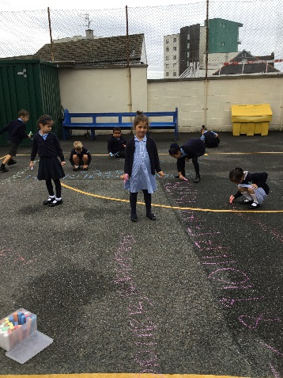
It has been another wonderful week of learning at Holy Cross! The children have enjoyed many exciting learning opportunities.

You will soon be able to make an appointment for our parent-teacher consultation evening - teachers are available to meet with you on Tuesday 2nd and Wednesday 3rd October 3.30-6.30. Appointments will fill fast so get in early to avoid disappointment. We will let you know when booking is open so watch this space!

The library summer reading challenge closes tomorrow! Hurry along to your local library so that your child can complete the challenge. They will receive a medal and will be awarded a certificate in celebration assembly on Friday 12th October.

Have a lovely weekend.
Mrs Potterton
dpotterton@holycross.plymouth.sch.uk

Liturgy in School
Please join us for whole school liturgy on Monday at 9.00 am.
The theme for our prayer and worship this week is:

A SURPRISING LEADER

Thank you, Jesus, for being such a good leader. Thank you for showing me how to put other people first and for showing me how much you love me.
Amen

IMPORTANT NOTICE

The front gate is now on a time controlled system.

The gate will be unlocked daily at the following times: -
8.25am to 8.50am to allow morning entry

3pm to 3.30pm to allow afternoon entry and exit

4.25pm to 4.40pm to allow collection of After School Clubs.

All you need to do is push the gate for entry, please do not prop the gate open. In between these times the gate is locked and you will need to buzz for entry and exit. On exit, the green button does not release the gate but alerts the office to open the gate for you so you need only press this once and we will unlock the gate.

Please note that we do not allow access in the mornings any earlier than 8.25am unless you have an appointment with a member of staff, where you will then need to report to the School Office.

Thank you for your understanding. This system is in place so that we can safeguard all of our children at all times.

Before School Breakfast Club

We are looking at ways to promote and expand our Before School Club. As you know, children can come to this club and receive a nutritious breakfast from 7.45 a.m. The cost is only £2.50 per day.

We would like to introduce a change in the way the children enter the school for the Before School Club from Monday. Instead of coming to the normal entrance gate, please go to the large red doors of the ‘church’ entrance coming off Beaumont Road. There your child will be greeted by a member of staff. Currently the children are entering the top playground, then having to open two large doors before walking through the staffroom to get to the kitchen area. We believe coming straight into the hall will be safer for the children and easier for parents.

The date for the next Holy Cross P.T.F.A. Meeting is Wednesday 26th September
@ 6pm.

Do come along and support your school’s P.T.F.A.

Please look out for the coming information on what is provided at the Before School Club as it might just suit your child.

**New Clubs
Starting this Term**

Thank you to everyone who expressed an interest in the School Choir which Miss Palarm is going to be running this term. Unfortunately due to the huge amount of interest for this club it has not been possible for everyone to obtain a space. You will have by now heard if your child has been successful in being placed in the choir. For those who have not been successful, names will be placed on a waiting list should a place become available.

Mrs Shaw will be starting a Homework Club which will run on a Wednesday lunchtime. Please let the School Office know if your child wishes to come along.

MEDICINES NOTICE

If your child requires medicine to be administered by the school, please ensure that you have completed a new medicine form for this term. Forms are available in the school office. A medicine form MUST be completed for each item that is administered to your child. Please feel free to contact Mrs Confue in the office if you have any questions regarding your child’s medication being administered in school. rachel@holycross.plymouth.sch.uk

REMINDER: Please remember to send your child into school with a coat each day. The lovely summer weather is now leaving us and it is important that all children have a warm and waterproof coat to wear at break times.

WHAT’S ON

SOUTH WEST CELEBRATE WEEKEND
A joyful and faith-filled event for all the family!
13th/14th October
Notre Dame School, Looseleigh Lane, Plymouth PL6 5HN
Main Speakers: Maria Heath, Fr. Oscar Ardila, Charles Whitehead
Separate streams for children & young people. Lively worship, drama, a variety of workshops, family Mass
……………………………………….
Online booking now open (Prior booking essential) More details: www.celebrateconference.org Email: southwest@celebrateconference.org Rebecca 01395 489902 or Susanne 01803 606256

Here is a list of some

Important dates confirmed for this year.
All information is available on our website calendar.

23rd September
Mary of the Cross Federation Mass

26th September
PTFA Meeting @ 6pm

2nd October
Parent/Teacher Consultation Evening

3rd October
Parent/Teacher Consultation Evening

4th October
Pizza & Poetry Evening

12th October
School Discos

19th October
Non-Pupil day – SCHOOL CLOSED TO PUPILS

22nd – 26th October
Half Term

29th October
Non-pupil Day – SCHOOL CLOSED TO PUPILS

28th November
Tempest Photography – School Photos

11th December
Christmas Production – 1.30pm & 7pm

12th December
Christmas Production – 7pm

13th December
Christmas Dinner Day

Thank you all for your support as always. Have a wonderful weekend.

Mrs Potterton and Mr Cotter

